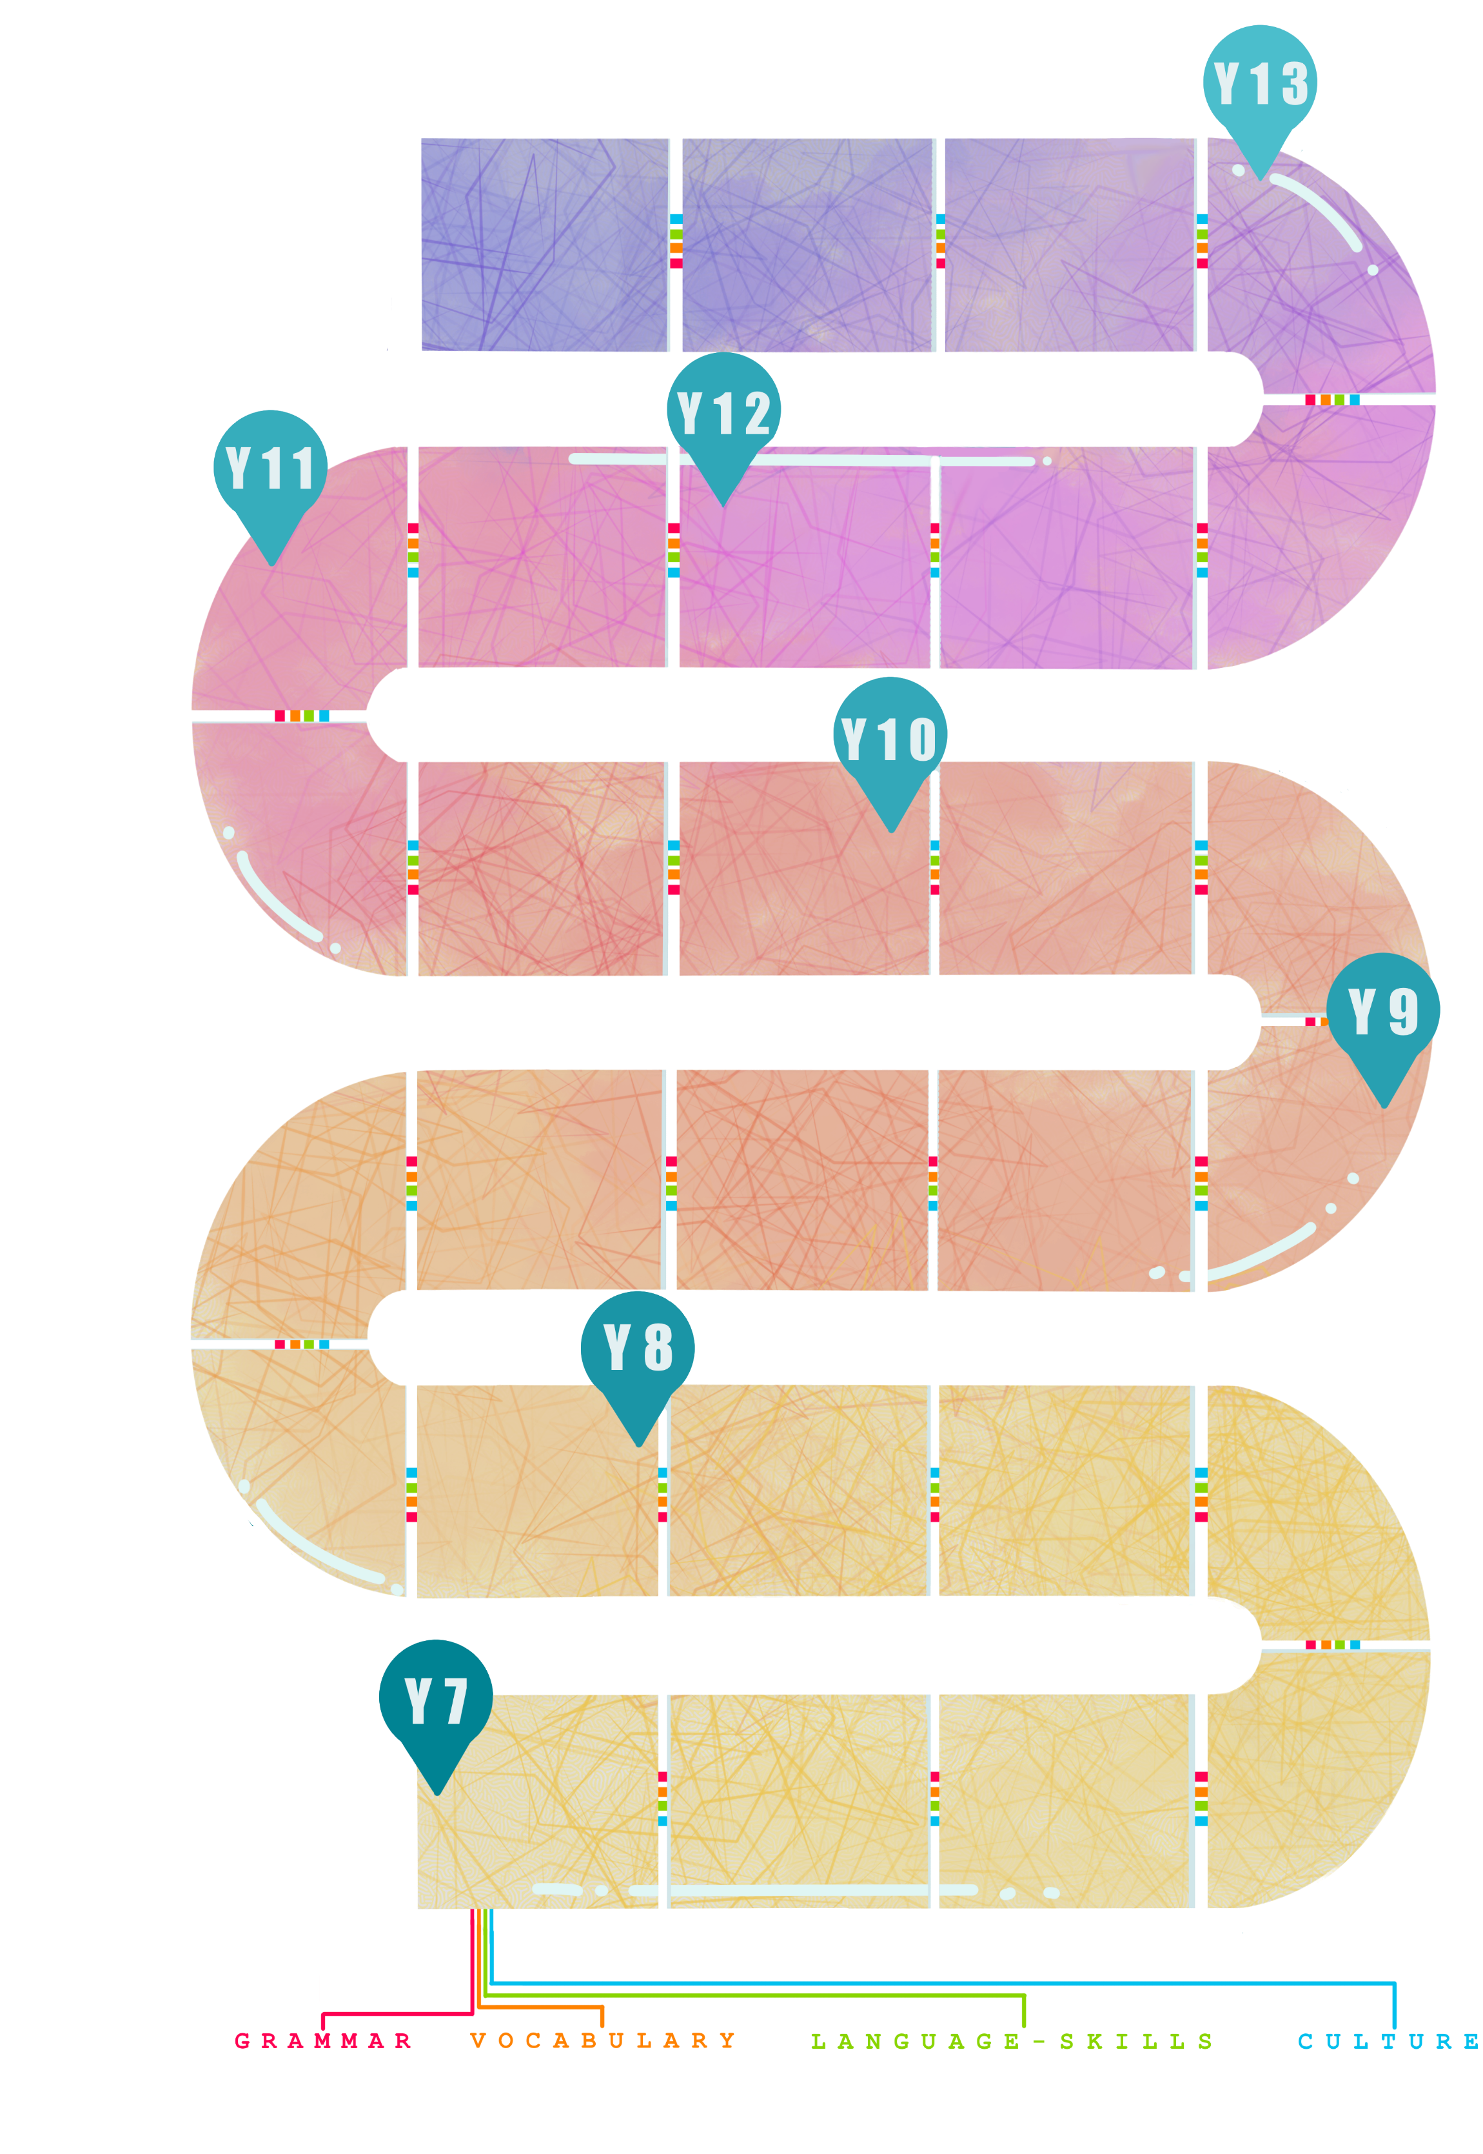
Free time
Present tense irregular verbs, Conjunctions.
House and home
Description, prepositions..

Study of film

Work
Future tense, other phrases to express future, subjunctive.

Current issues
Development of more complex vocabulary, new tenses.

Awareness of different ways of life in French-speaking countries.
Individual Research Project
Planning, research and preparation for the IRP in speaking.

Artistic culture
Research of artistic culture in society.
Current trends
Key GCSE grammar, more complex vocabulary.
Information given at appropriate times regarding career and travel opportunities with French.
CAREERS
Using MFL in everyday life.
Awareness of acquisition of different skills gained by continuing to study French at GCSE.
Information regarding higher education opportunities with French plus future plans.
Murder mystery
CLP – Maths, Drama to develop problem solving skills.
Study of novel

Political life
Research of political systems in society.

International events and environment
Passive, I.O. pronouns.

School
Opinions, imperative, modal verbs.
Holidays
Pluperfect tense, conditional tense, present participle.

Local area
Asking questions, negatives, future tense.

Life at home
Modal verbs, asking questions with ‘tu’ and ‘vous’.

Free time
Combining tenses.

Relationships
Reflexive verbs, conjunctions, adjectives.
Exchange visit
Understanding of family life, customs.
Going out
Verbs In the third person in perfect tense.
Health
Singular and plural, imperative.
Activities
Statements and reasons, word order.

Shopping and food
Transactional phrases, quantities.
Holidays

Perfect tense.

Cultural research
Life in different countries.

Town
Building vocabulary bank.

Family and Friends
More detailed sentences.
School
Present tense, short sentences, opinions.
Myself
Key generic vocabulary, short Q&A.
FRENCH – LEARNING JOURNEY
Skills development
Listening, Speaking, Reading, Translation, Writing.

