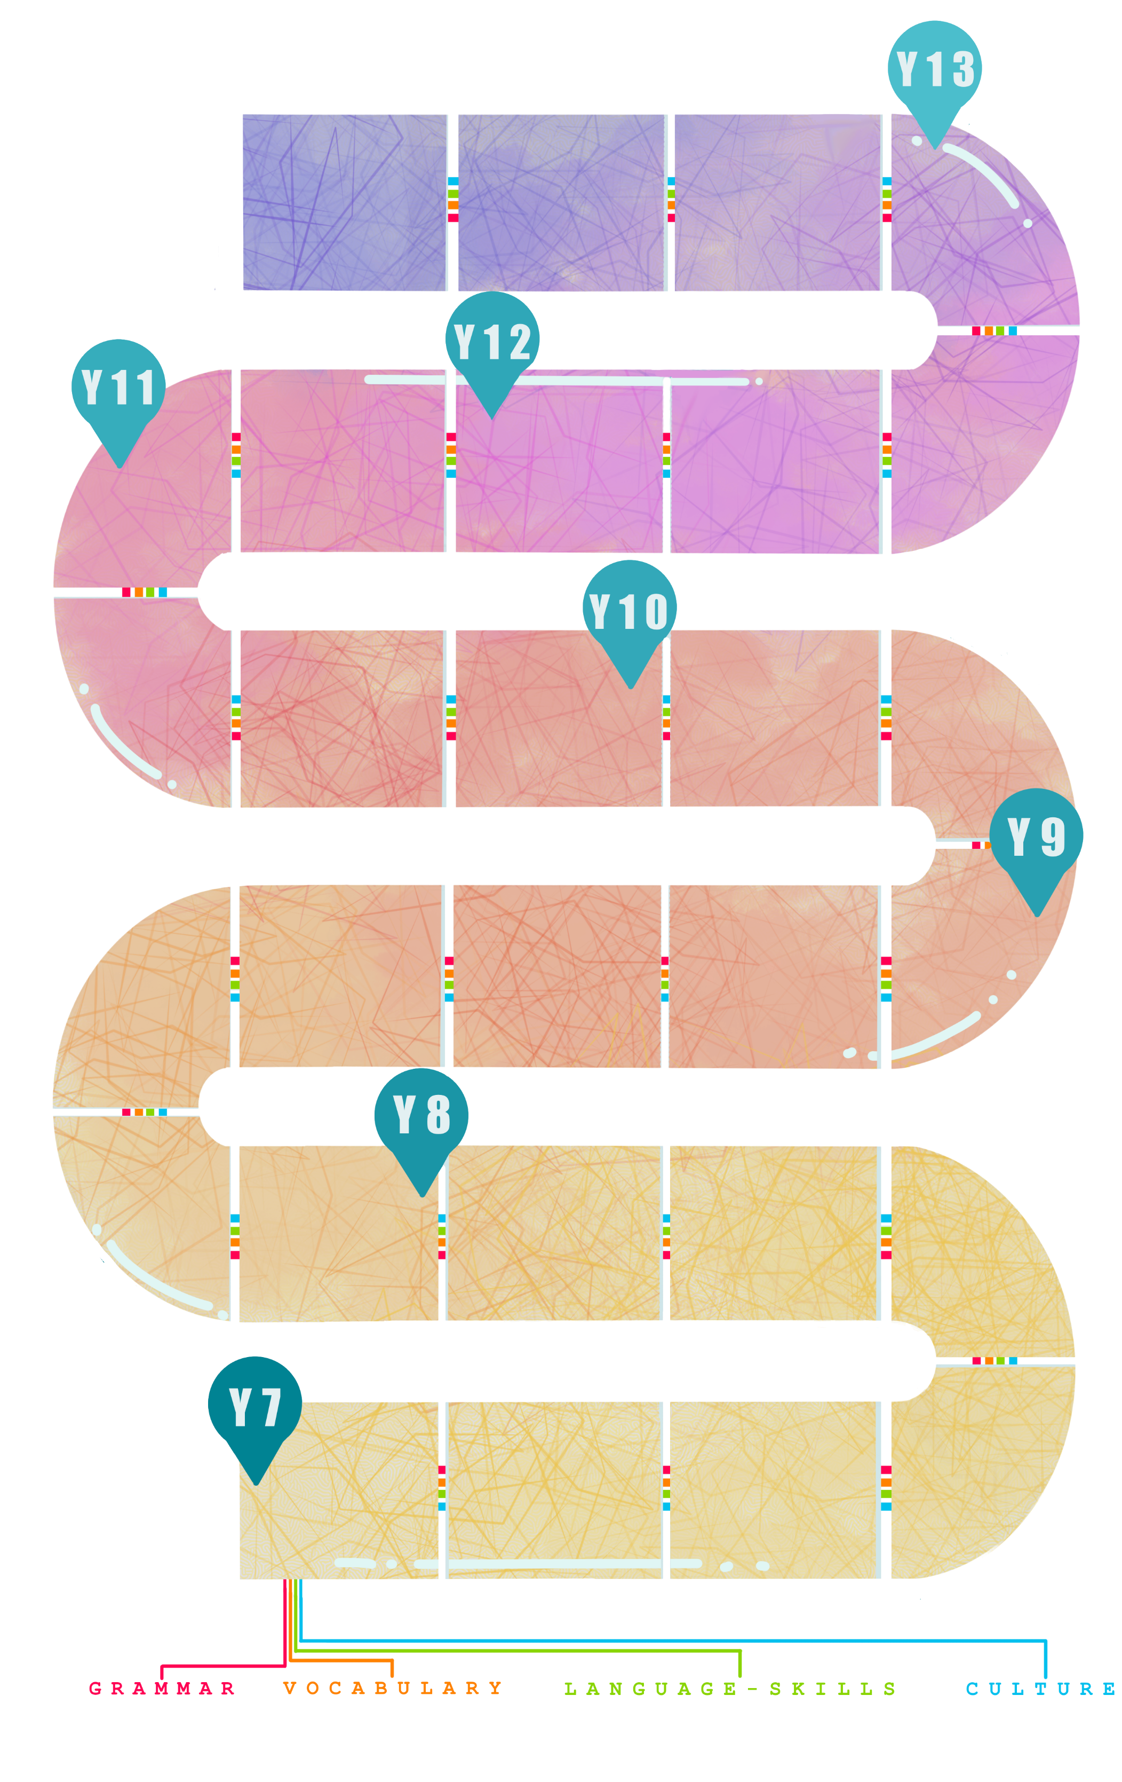
House and home
Description, prepositions.

Free time
Present tense irregular verbs, Conjunctions.
Free time
Combining tenses, plural nouns.
Shopping and food
Transactional phrases, quantities.
Awareness of acquisition of different skills gained by continuing to study German at GCSE.

Awareness of different ways of life in German-speaking countries.
Current issues
Development of more complex vocabulary, new tenses.

Skills development
Listening, Speaking, Reading, Translation, Writing.
Individual Research Project
Planning, research and preparation for the IRP in speaking.

Study of film

Artistic culture
Research of artistic culture in society.

Current trends
Key GCSE grammar, more complex vocabulary.
Information given at appropriate times regarding career and travel opportunities with German.
CAREERS
Using MFL in everyday life.
Information regarding higher education opportunities with German and future plans.
International events and environment
Conditional, adjectival nouns, passive.
Holidays
Pluperfect tense, genitive case, infinitive constructions with ‘zu’.

Work
Future tense, other phrases to express future, masculine and feminine nouns

Planning a trip
Transactional phrases, comparatives and superlatives, imperative.
Life at home
Separable verbs, register, prepositions with accusative and dative, ‘wenn’ clauses.
Family and Relationships
Reflexive verbs, possessive adjectives, dative case
School
Opinions, asking and answering questions, modal verbs.
School
Present tense, short sentences, opinions.
Family and Friends
More detailed sentences, intensifiers.
GERMAN – LEARNING JOURNEY
Murder mystery
CLP – Maths, Drama to develop problem solving skills.
Study of novel

Political life
Research of political systems in society.
.

Exchange visit
Understanding of family life, customs.
Going out
Verbs In the third person in perfect tense.
Health
Singular and plural, imperative.
Activities
Statements and reasons, word order.

Holidays

Perfect tense.

Cultural research
Life in different countries.

Town
Building vocabulary bank.

Myself
Key generic vocabulary, short Q&A.

