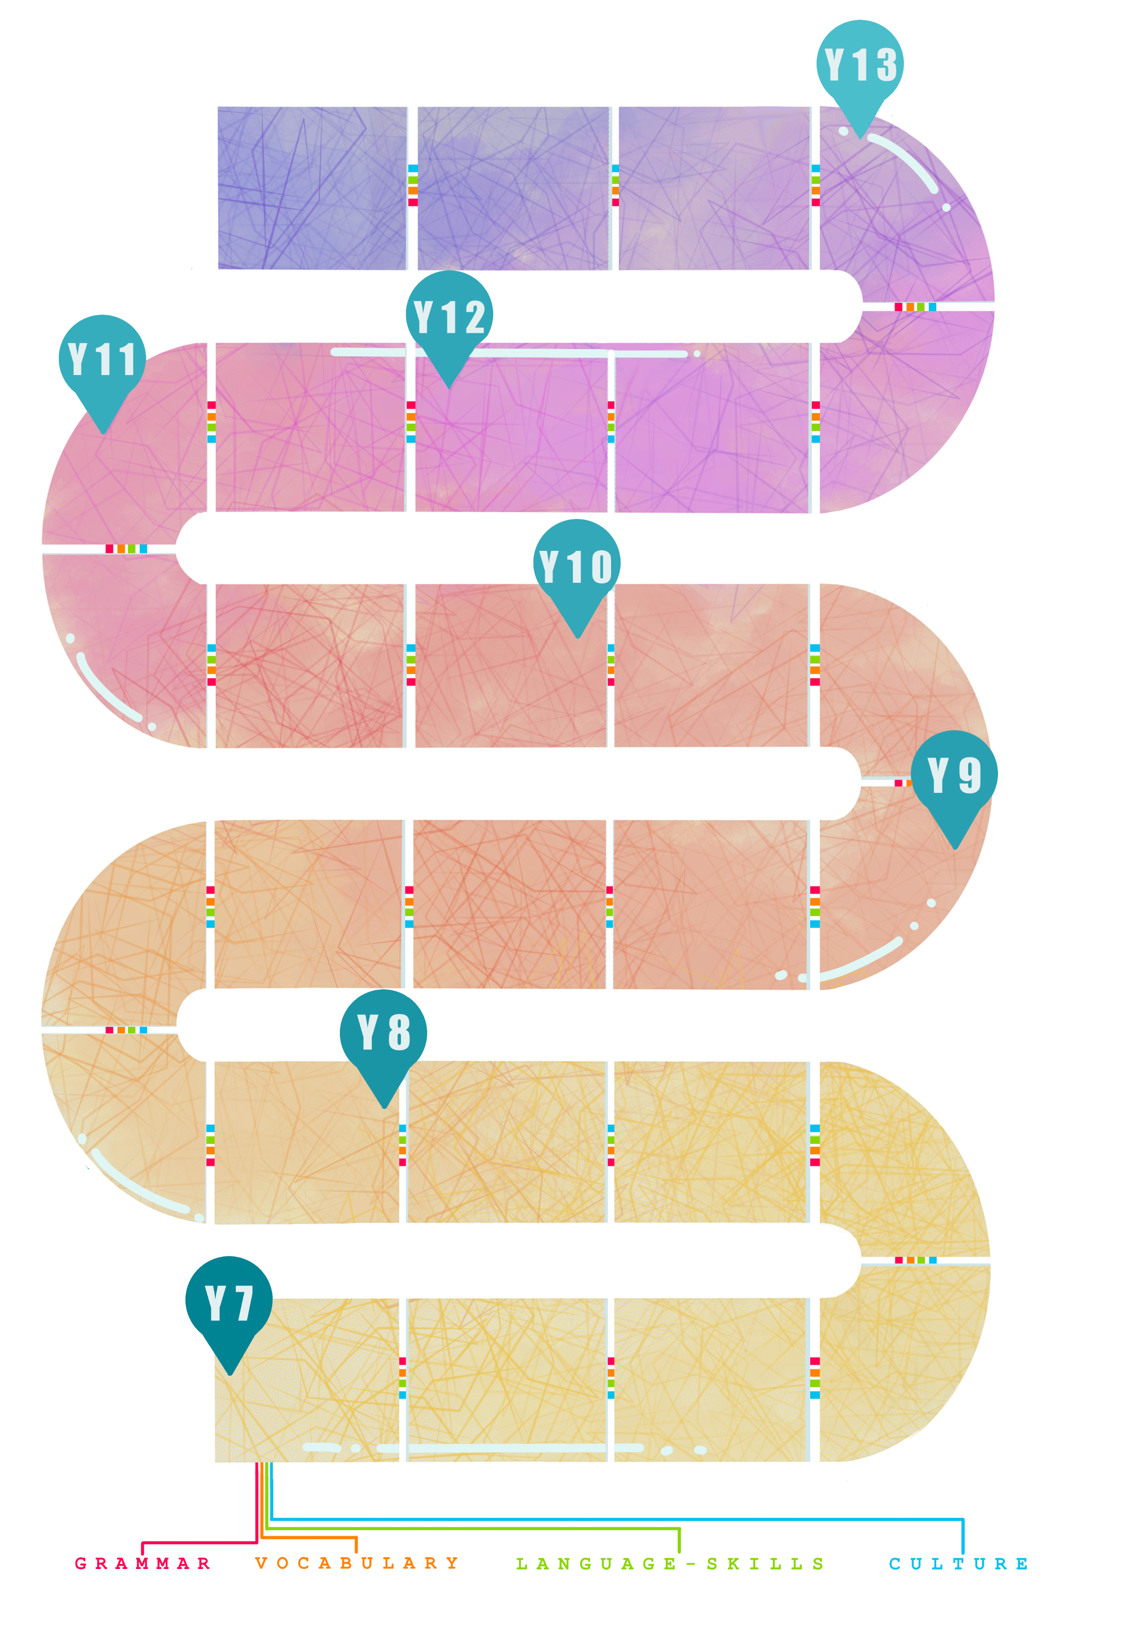
Family and friends
Descriptions, Reflexive verbs, Opinions.
Awareness of different ways of life in Spanish-speaking countries.
Visiting Barcelona
Using ‘se puede’ to say you can. Understanding ‘Estar’, justifying opinions.
Fashion
Noun/adjective agreement, comparatives and superlatives.
Food
Different register with ‘tú’ and ‘usted’, high numbers, combining tenses.

Holidays
Preterite tense of -AR verbs, Opinions in the past.
Going out
Near future, phrases with infinitives, Sequencing words.
Holidays
Preterite, imperfect tense, opinions.
Myself
Key generic vocabulary, short Q&A.
Family and Friends
More detailed sentences.
School
Present tense, short sentences, opinions.
Current issues
Development of more complex vocabulary, new tenses.

Individual Research Project
Planning, research and preparation for the IRP in speaking.
School
Comparative and superlative, Near future, negatives.

Study of film

Artistic culture
Research of artistic culture in society.
Current trends
Key GCSE grammar, more complex vocabulary.
Information given at appropriate times regarding career and travel opportunities with Spanish.
CAREERS
Using MFL in everyday life.
Awareness of acquisition of different skills gained by continuing to study Spanish at GCSE.
Skills development
Listening, Speaking, Reading, Translation, Writing.
Study of novel

International events and environment
Subjunctive, reasons, pluperfect.
Work
Subjunctive with ‘cuando’, I.O. pronouns.

Life at home
Passive, expressions with infinitive.
Local area
Future and conditional, asking and answering questions, idioms.

Family and Relationships
Present continuous, connectives, ‘para’ with infinitives.
Free time
Present tense irregular verbs, opinions with infinitives.
House and home
Description, prepositions..

SPANISH – LEARNING JOURNEY
Information regarding higher education opportunities with Spanish and future plans.
Murder mystery
CLP – Maths, Drama to develop problem solving skills.
Political life
Research of political systems in society.

Free time
Perfect tense, building dialogues.

Cultural research
Life in different countries.

Town
Building vocabulary bank, longer sentences.

